EXPERIMENT 9
EXPLORING AI-ASSISTED FEATURES AND BUILT-IN ANALYTICS (ZIA) IN ZOHO CREATOR
Gym Membership Enrollment & Front Desk Management

Parikshith P
Reg. No: 2116241401062
Computer Science and Business Systems
Rajalakshmi Engineering College, Chennai

Aim
To explore AI-assisted features available in Zoho Creator using Zia and create dashboards and reports to analyze gym membership data.

Description
Zoho Creator is a low-code application development platform that provides AI-assisted features through Zia. These features help users analyze application data and simplify application development. Built-in reports, charts, and dashboards help visualize information and support decision-making.
In this experiment, the Gym Membership Enrollment & Front Desk Management application was used to explore Zia and built-in analytics. The membership form stores member details such as name, age, membership type, phone number, and email address.

Procedure
- Open the Gym Membership Enrollment & Front Desk Management application in Zoho Creator.
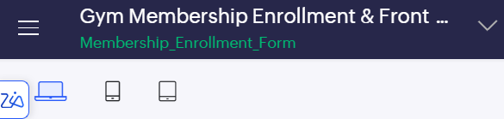
Figure 1. Gym Membership Enrollment & Front Desk Management application opened in Zoho Creator.
- Open the Build Agent (Zia) panel and enter a prompt to analyze the membership application and generate a dashboard.
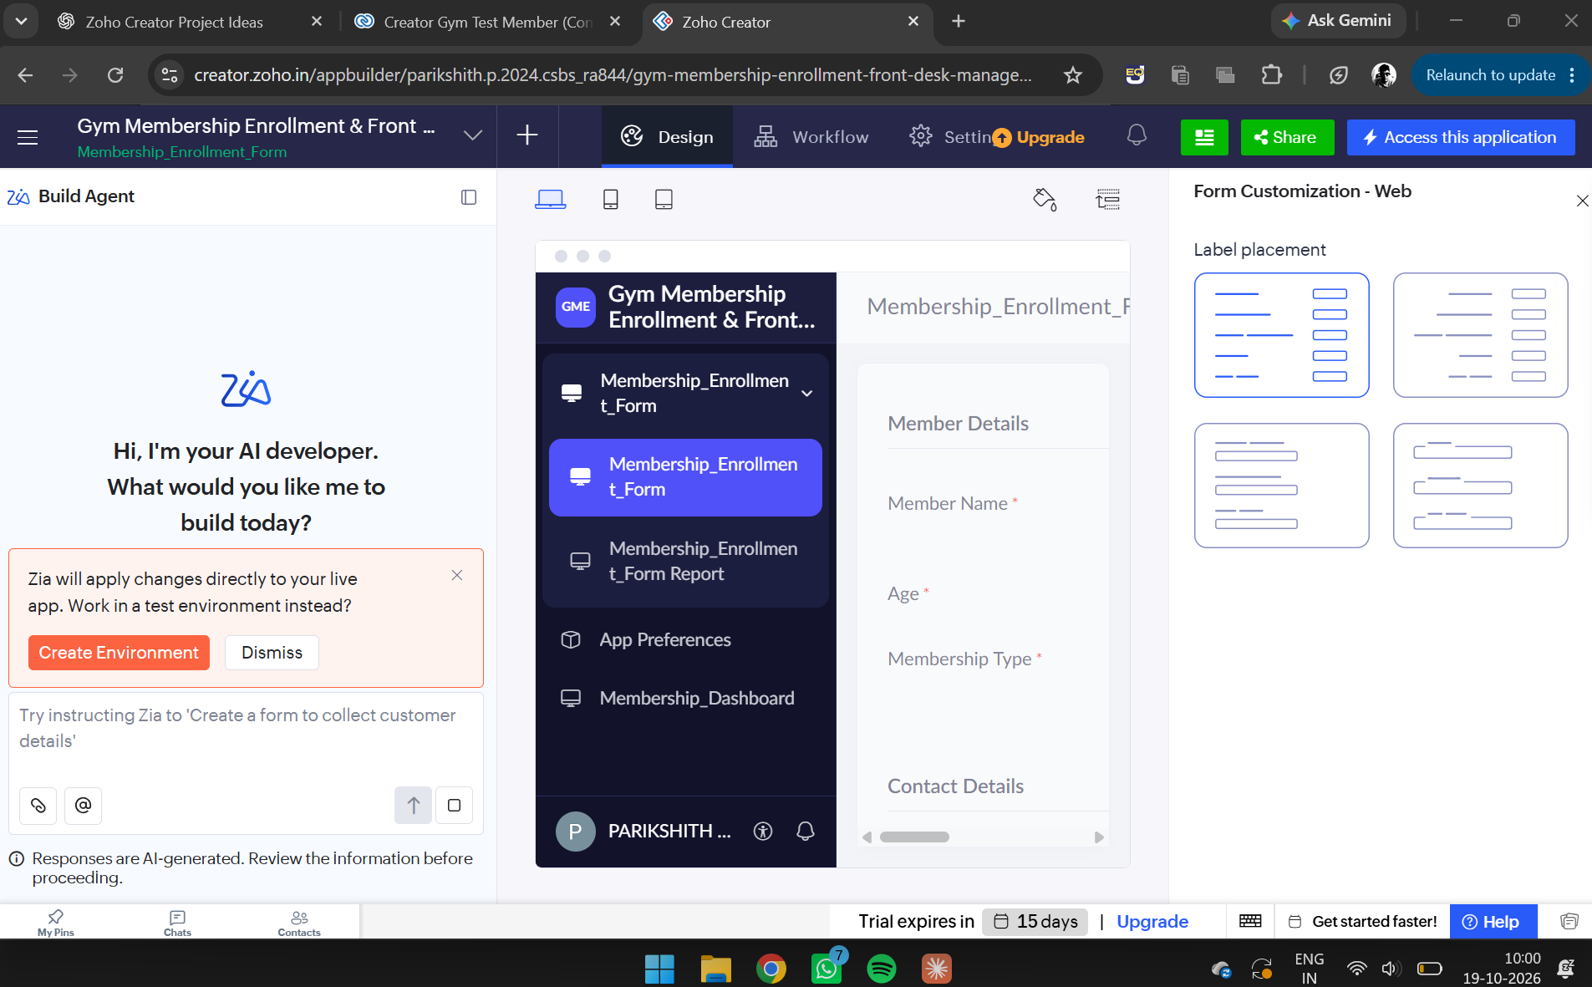
Figure 2. Build Agent (Zia) panel opened, ready for a prompt.
- Explore the AI-assisted feature. The dashboard-generation attempt did not complete successfully because of a validation or tool-usage limitation.
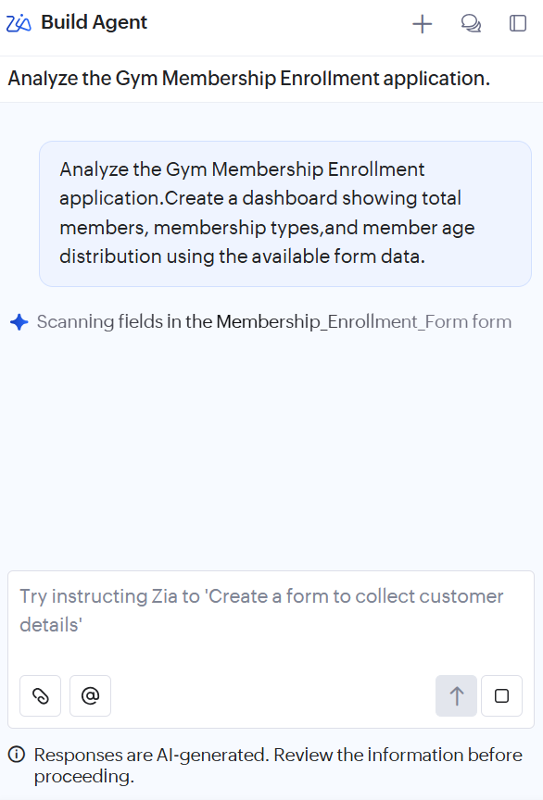
Figure 3. Prompt submitted to Zia asking it to analyze the application and create a dashboard, with Zia scanning the form fields.
- Open the Membership_Enrollment_Form Report to view the stored membership records.
- Add sample member records and verify that they appear in the report.
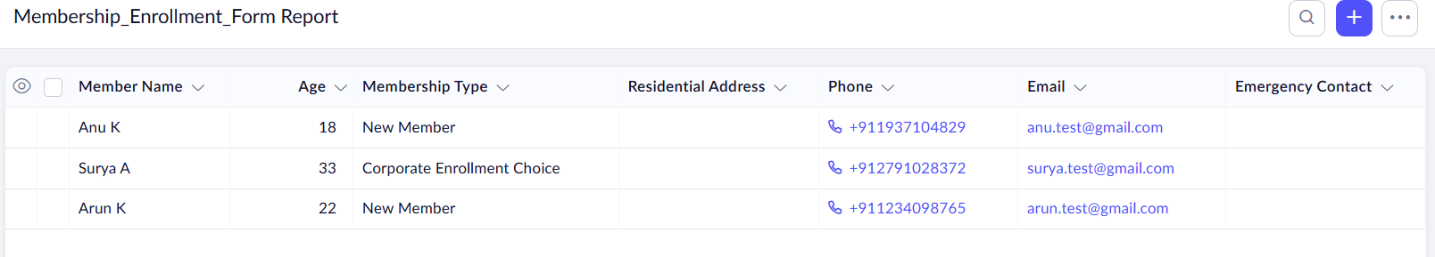
Figure 4. Membership_Enrollment_Form Report showing the three sample member records.
- Open Membership_Dashboard to view the built-in charts.
- Observe the pie chart representing membership categories and the bar chart representing membership plans.
- Verify that the dashboard visualizes the available membership data.
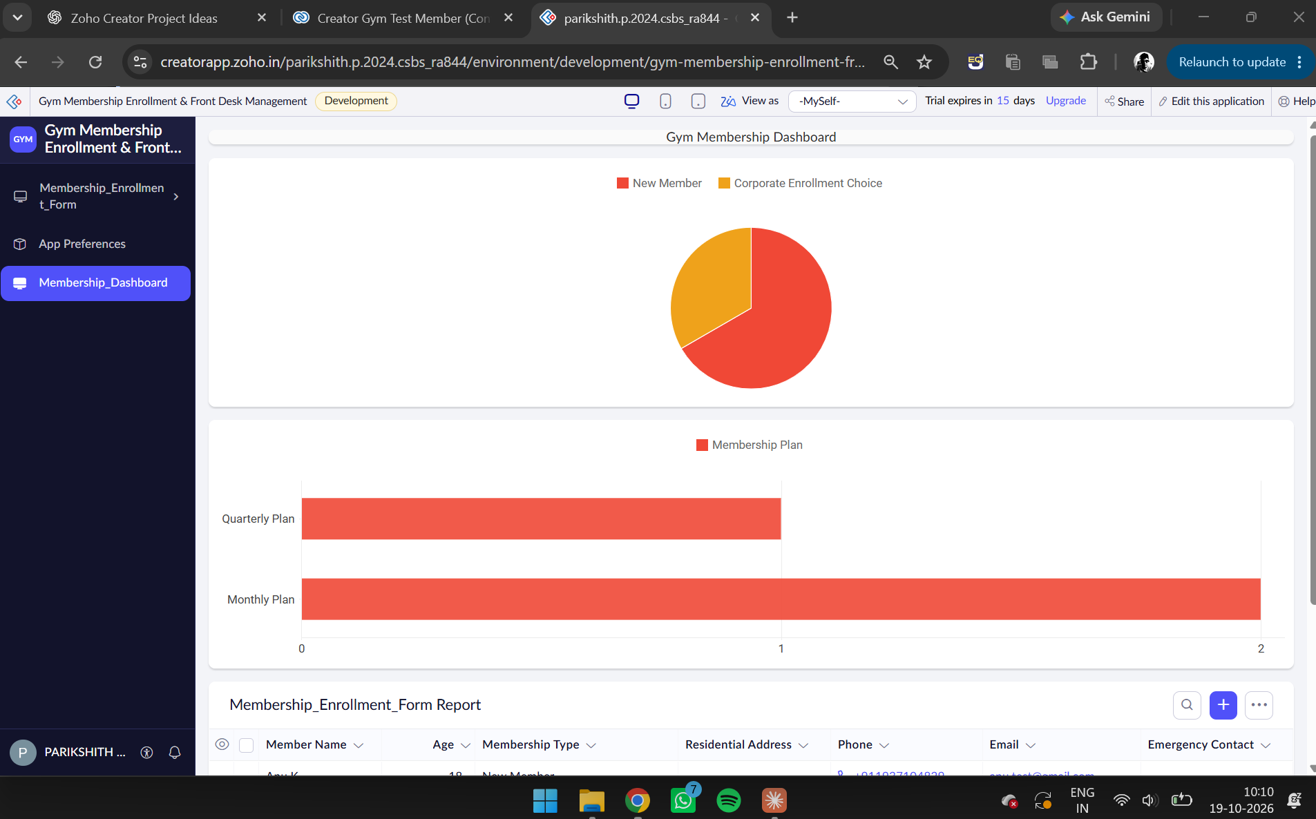
Figure 5. Membership_Dashboard showing the pie chart of membership types, bar chart of membership plans, and the report below.

Sample Data
Member Name | Age | Membership Type
Anu K | 18 | New Member
Surya A | 33 | Corporate Enrollment Choice
Arun K | 22 | New Member

Output
The membership report displayed three member records with their details. The dashboard displayed:
- A pie chart showing the distribution of membership types.
- A bar chart showing the distribution of membership plans, including Monthly Plan and Quarterly Plan.
- A report section displaying membership records.

The Zia panel was explored, but AI-generated dashboard creation was not completed successfully.

Result
Thus, the AI-assisted features and built-in analytics of Zoho Creator were explored using the Gym Membership Enrollment & Front Desk Management application. Membership reports and dashboard charts were used to visualize the available data and support basic analysis.

